Name: Pranali Sonawane
Subject: CCNA
Lab – password recovery Scenarios :
First, we have taken one Routers and one server . The Router are connected to the server using Crossover cables.
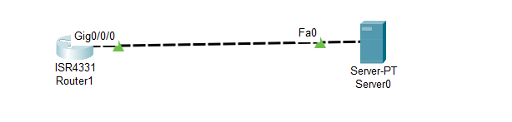
In the same setup, use a backup configuration to perform password recovery.
Router 1 --physical --First OFF then ON Router --- CLI-Tap on screen then ctrl+shrift+6+c
Rommon 1 —confreg 0x2142
Rommon 2 ---reset
Router>enable
Router# show startup-config
Using 699 bytes
version 16.6.4q
no service timestamps log datetime msec
no service timestamps debug datetime msec
no service password-encryption
hostname ccna
enable secret 5 $1$MERr$Bok4KDEVuLXJRq00M/
ip cef
no ipv6 cef
!
end
Router# configure terminal
Enter configuration commands, one per line. End with CNTL/Z.
Router(config)# enable password AWS
Router(config)# exit
Router# show running-config
Building configuration...
Current configuration : 671 bytes
version 16.6.4
no service timestamps log datetime msec
no service timestamps debug datetime msec
no service password-encryption
!
hostname Router
!
enable password AWS
no ip cef
!
end
Router#reload

Router> en
Router# copy startup-config running-config
ccna# config t
Router(config)# enable secret JCP
Router(config)# hostname Pranali
Pranali(config)# end
Pranali# configure terminal
Pranali(config)# config-register 0x2102
Pranali(config)# end
Pranali# copy running-config startup-config
Pranali# reload
✅ After reload:
You should see:
Pranali>

